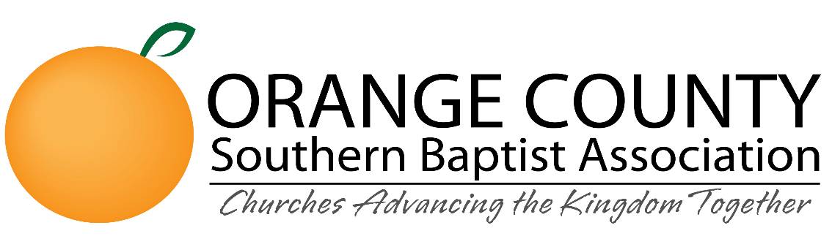
Gateway Scholarship Application
*It is required to answer all questions below*

Today’s Date: Select Today’s Date

Full Name (First Middle Last): Enter your full name

Date of Birth (mm/dd/yyyy): Select Date of Birth

Gateway Scholarship ID #: Enter ID #

Phone Number: Enter Phone #

Email: Enter Email Address

Marital Status: Choose Marital Status

Member of an OCSBA Partner Church?: Yes/No

Name and Address of Church: Enter Church Address

Pastor’s Name, Phone, Email: Enter Pastor’s Information

Name of College/University: Enter Name of College/University

Undergraduate Degree Obtained?: Yes/No

Gateway Degree Sought: Type Here

Number of Units Enrolled for the Semester: Type Here.

What is your current accumulated GPA at Gateway Seminary? *Or what was your final GPA in College/University?: Type Here

Describe your salvation experience: Type Here

Describe your call to Ministry: Type Here

How are you currently serving in Ministry?: Type Here

In what ministry setting do you feel called to serve after graduation from Gateway Seminary?: Type Here

Please describe your financial situation and why a scholarship from the OCSBA to Gateway Seminary would be helpful to you at this time: Type Here

Please email your completed form along with PDF of current resume to info@ocsba.org or mail to 250 N Golden Circle Drive #101 Santa Ana, CA 92705

